**Pi Representation**

Euler Number [e] = 2.718281828459045

**Taylor Expansion**

$$e^{x}=1+\frac{x}{1!}+\frac{x^{2}}{2!}+\frac{x^{3}}{3!}+…, -∞<x<∞$$

$$f\left(z\right)=\sum_{n=0}^{∞}{\frac{f^{\left(n\right)}\left(a\right)}{n!}{\left(z-a\right)}^{n}}$$

At X =1 we get Euler number [e] = 2.718281828459045 in Machine uses 15 Decimal places

$$2.718281828459045=1+\frac{1}{1!}+\frac{1}{2!}+\frac{1}{3!}+…, untill=≤∞$$

“Until infinity” 🡪 is defined by each machine capacity for how many decimal places it can handled

For example, in machine that have max double = 1.7976931348623157E+308

And (170)! = 7.257415615308004E+306

Therefore; (171)! = will be exceeding its precision capacity 🡪 (171)! = ∞

Because its value will exceed the value that can be represented in double datatype.

Therefore, any bigger value for a factorial > 170 no change in the Taylor Expansion (value will remain the same)

Therefore, this Euler number [e] is only a sum series of factorial reciprocals, and its value is limited by the machine capacity

$$f\left(z\right)=\sum_{n=0}^{∞}{\frac{f^{\left(n\right)}\left(a\right)}{n!}{\left(z-a\right)}^{n}}$$

From Leibniz-series

$$\frac{π}{4}=1-\frac{1}{3}+\frac{1}{5}-\frac{1}{7}+\frac{1}{9}-\frac{1}{11}+…$$

$$π=3*{\left(1+\frac{1}{1!}+\frac{1}{2!}+\frac{1}{3!}+…\right)}^{0.046117597181290354 }, untill=≤∞$$

$$π=3*e^{2.6423436797723589 °}$$

This relation between e and $π$ shown next in Leibniz graph

If we reversed the scientific notation by multiply 1000000000000000

We will series sum will reach value = 1718281828459046.8

And if we subtract pi from this value we will get

y - pi = 1718281828459043.5

Zeta function is One case from Dirichlet’s generalization

If φ(S) use -0.5 instead of -1

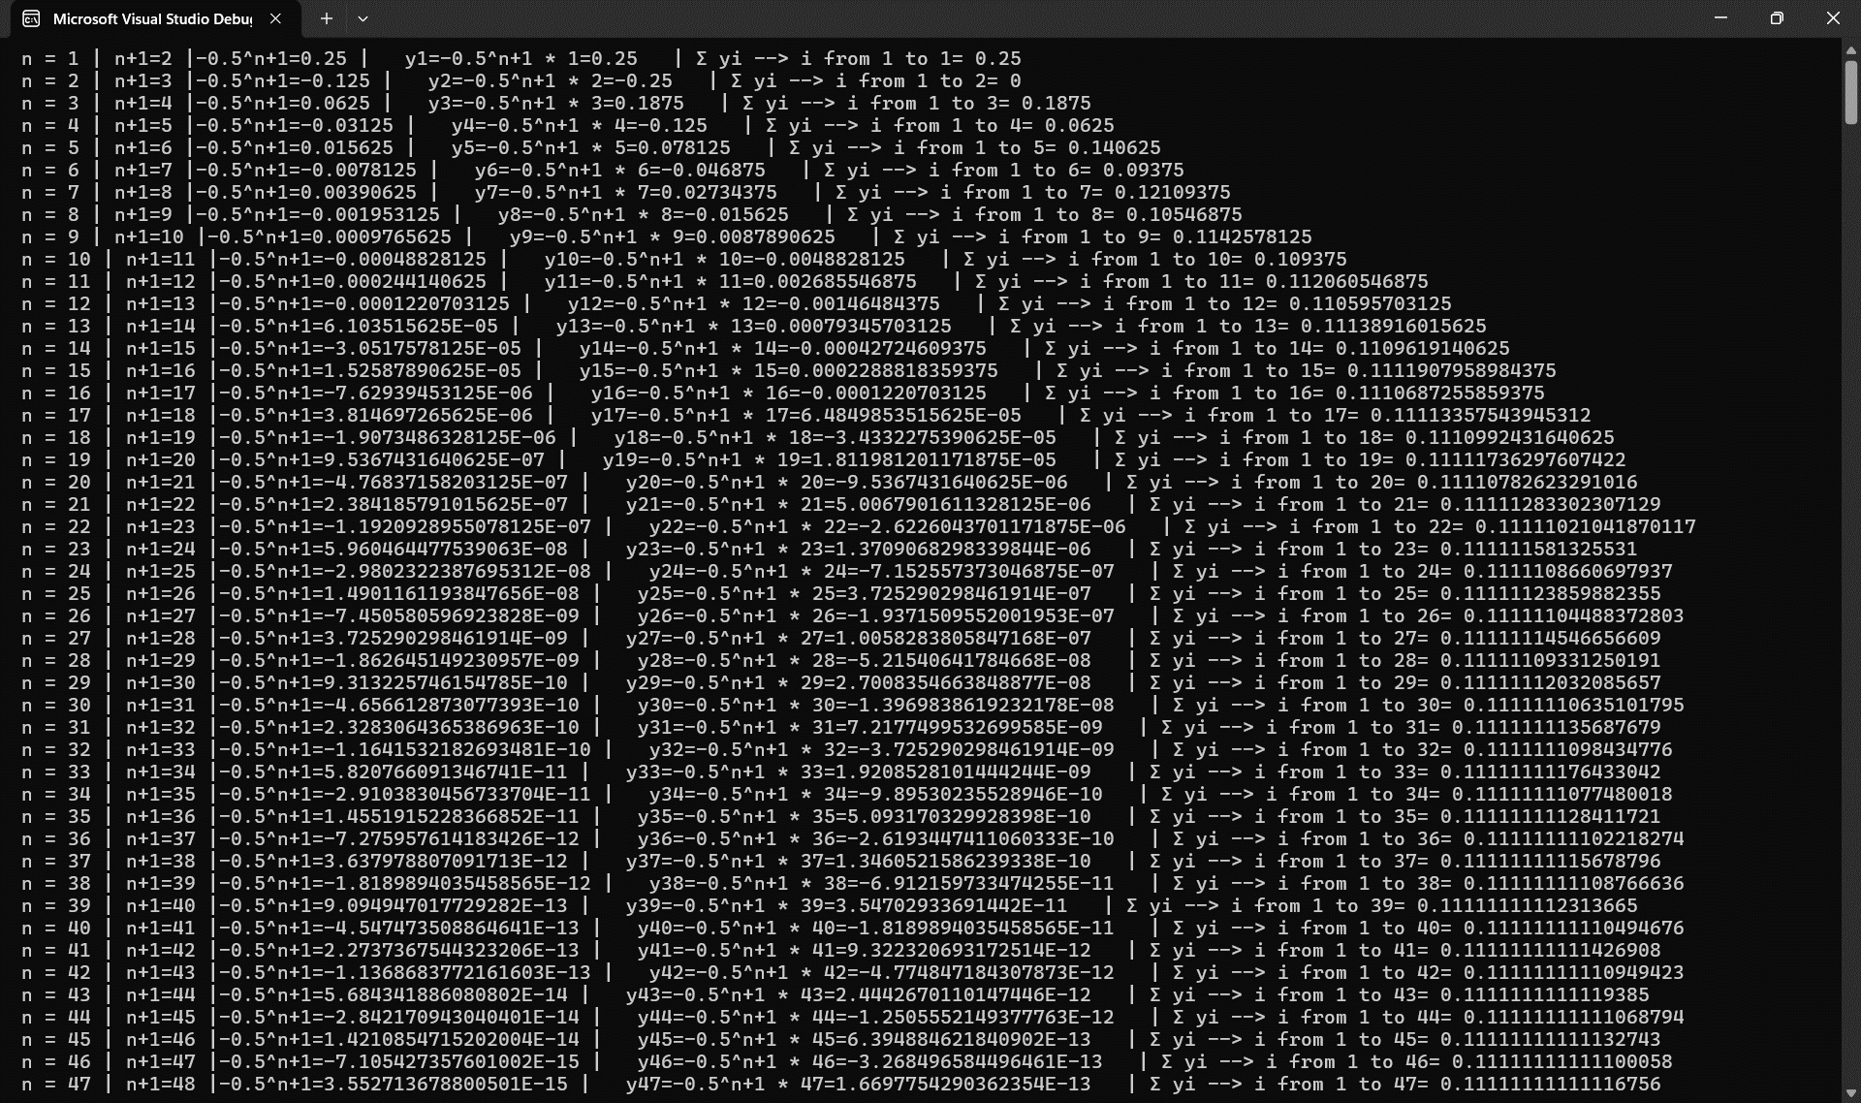

This means this sum converge to Zero if we subtract 1/9.0

Converge to n/2

In theory, these terms should be changing between -1 and 1 but the calculations of 1/n and adding all terms together at n = 49 we will see that

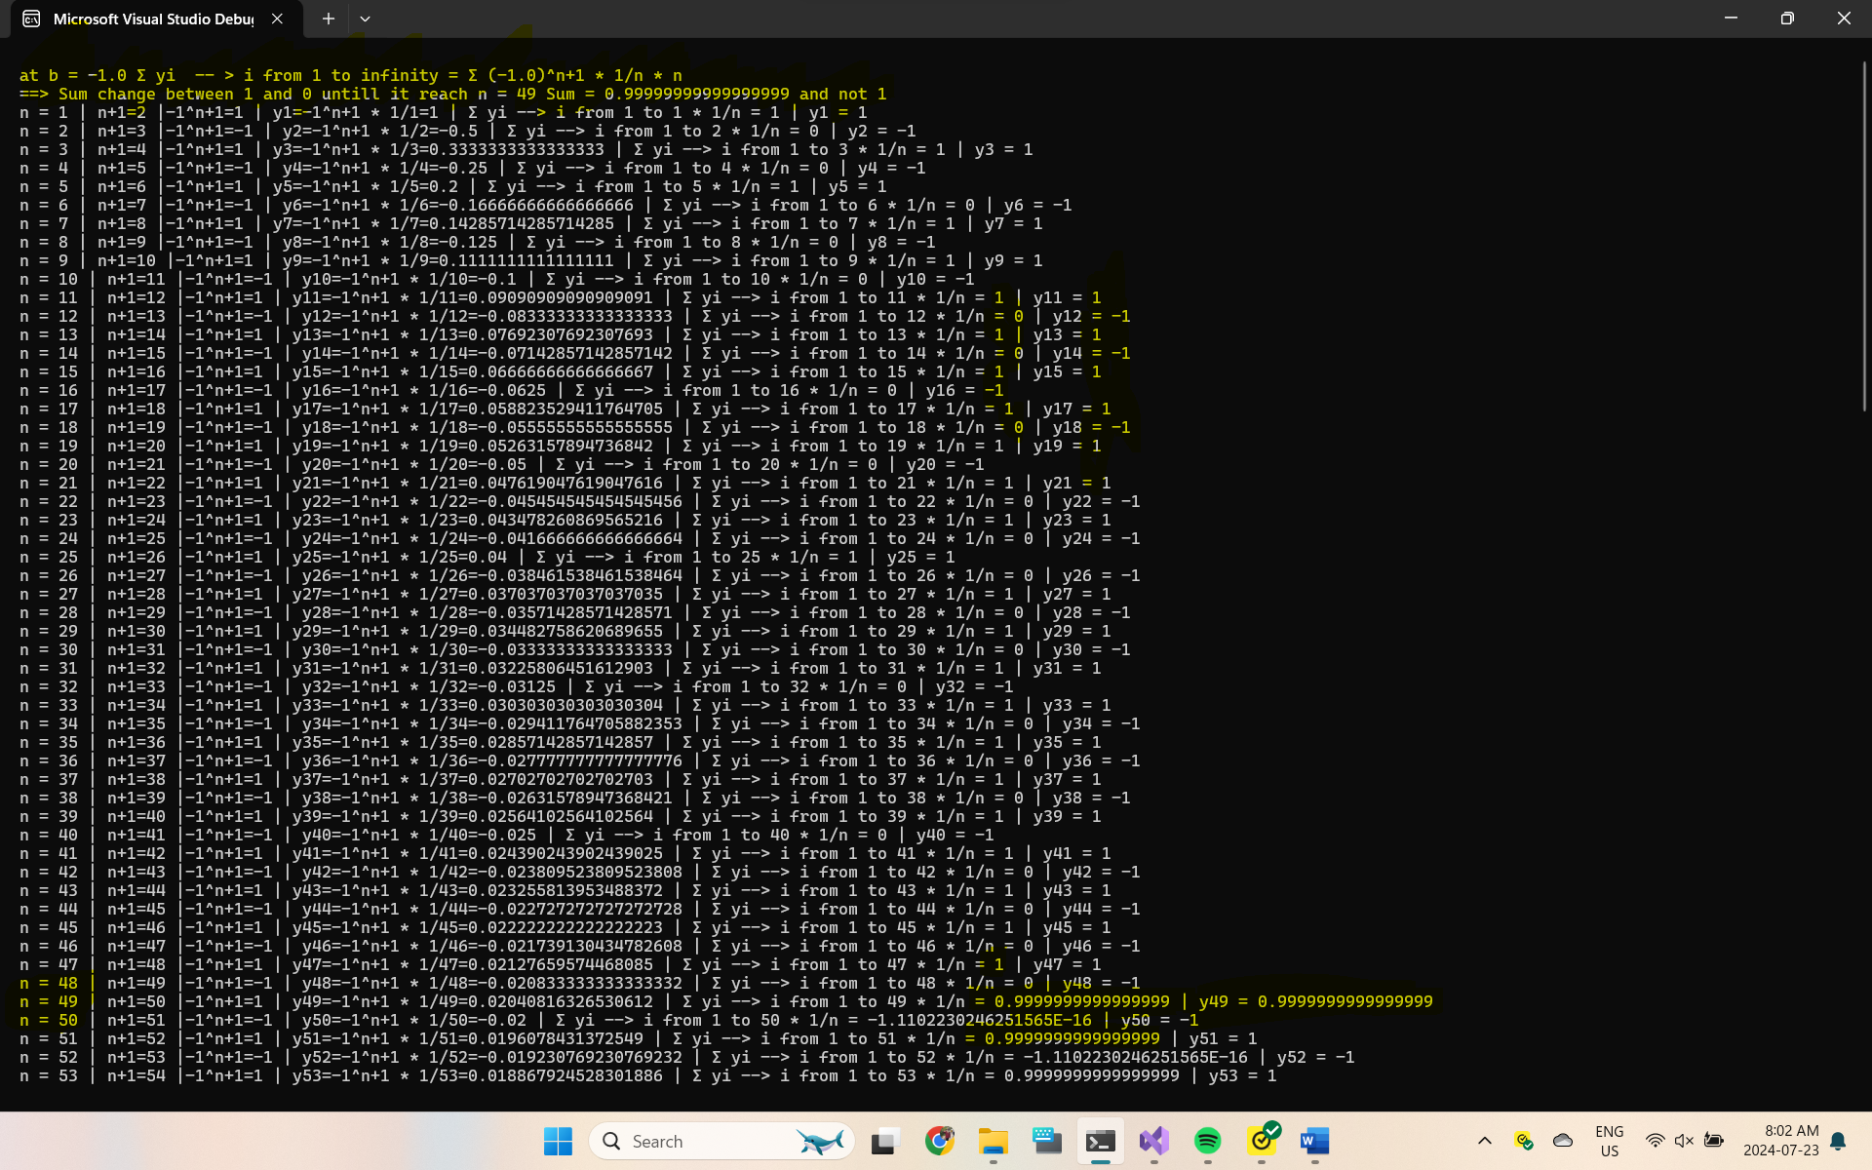

The other math constant [π] if it is a constant then it also related to machine capacity of calculations

Therefor for sure it can be represented as a summation series like Tylor series

